Name(s)_______________________________________________ Period ______ Date ___________________

|  |  |  |
| --- | --- | --- |
|  | **Activity Guide - Packets** |  |

## Why Packets?

When you send messages over the Internet there’s always a chance for errors. If you’re sending a huge file, and in the middle of the transmission you have a single error, you’d need to resend the entire file. The solution to this problem is to split the message into smaller chunks called packets. While errors could still occur, now they’ll only affect the single packet, rather than the entire message. This of course introduces new challenges that we’ll explore in this activity.

## Protocol 1 - Just Send All the Packets

Write a single sentence that uses 5 - 10 packets. Send all the packets at once to your partner. Then click “Log Browser”. **Set the Router logs to “show my traffic” and “show all routers”**

Question 1: Do all of the packets in your sent messages always follow the same path? If not, describe at least two different paths packets took.

We learn that messages don’t always take the same path to get from point a (my router) to point b (their router). We also understand that messages travel on the internet not as a single piece, but in chunks. These chunks are packets. Packets are chunks of data with metadata used to route and reassemble information on the internet. These packets are sent down the datastream in pieces. With all of this in mind, I am confused why when I send a message from my router’s IP address (1.4) to another student’s IP address (1.8). When I view the logs (show all traffic and show all routers), I see that the messages were not sent more than once (no redundancy), and there is no abnormal path taken. (see image).

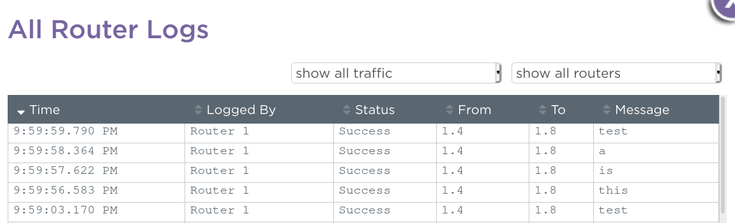

When I look at some old messages (not sent by me nor to me), I do see redundancy, but nothing else that is abnormal, and the path taken seems the same as how mine was.

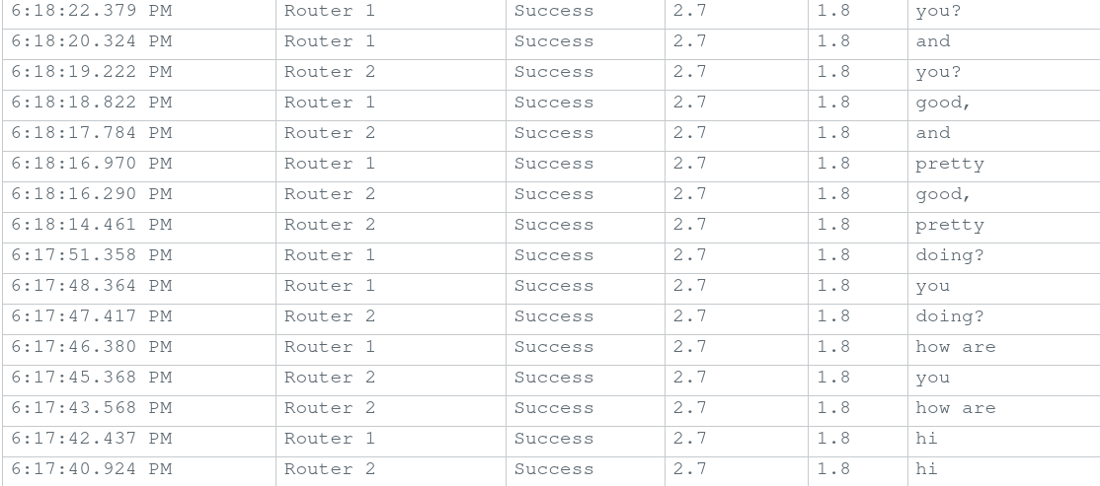

Question 2: Did every packet arrive in the correct order? Describe what went wrong and whether your partner was able to read the message. If neither you nor your partner had an issue try sending another message.

Every packet that I sent and every packet another student sent was delivered in the same order that it was sent.



Both parties were able to read the message correctly. If I send another message, the order is the same, but I did have a dropped packet.

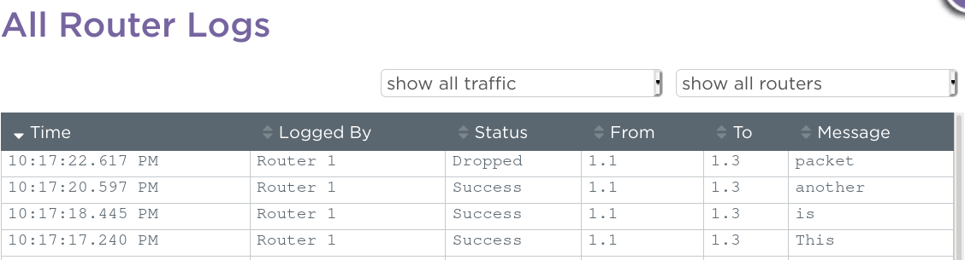

## Protocol 2 - Check for Errors

Create a protocol that will solve the problems you saw with Protocol 1 by doing some error-checking. The sender should be able to construct a single multi-packet message that is sent at once. Afterwards they can keep communicating to fix any errors in the transmission. Things to consider:

* How will the receiver know the order of the packets or if any are missing?
* How will the receiver request missing packets and what will the sender do in response?
* How will both sender and receiver know the full message arrived successfully?

**Write the details of your protocol in the space below or the back of this sheet.**

My protocol would resemble the TCP, Transmission Control Protocol. TCP takes inventory of all packets in the data stream to ensure they are successfully sent and received. Every packet with my protocol includes a number out of the total number like 1/5 if there are five packets. If one of the five packets is missing, the message would not be sent. The receiver would know the order of the packets because they are numbered. The receiver would not receive any missing packages because the message would not be sent if a packet is missing. The receiver would request the missing packets by asking all of the packets again. The sender would send all of the packets again once the receiver requests them again. Both the sender and receiver would know if the message was delivered successfully if the message was delivered at all.